The Irish Guards arrive in Tunisia

17th March 1943: The Irish Guards celebrate St Patricks Day in a last celebration before battle
MAR 17

SAVE |  | ▷ LISTEN

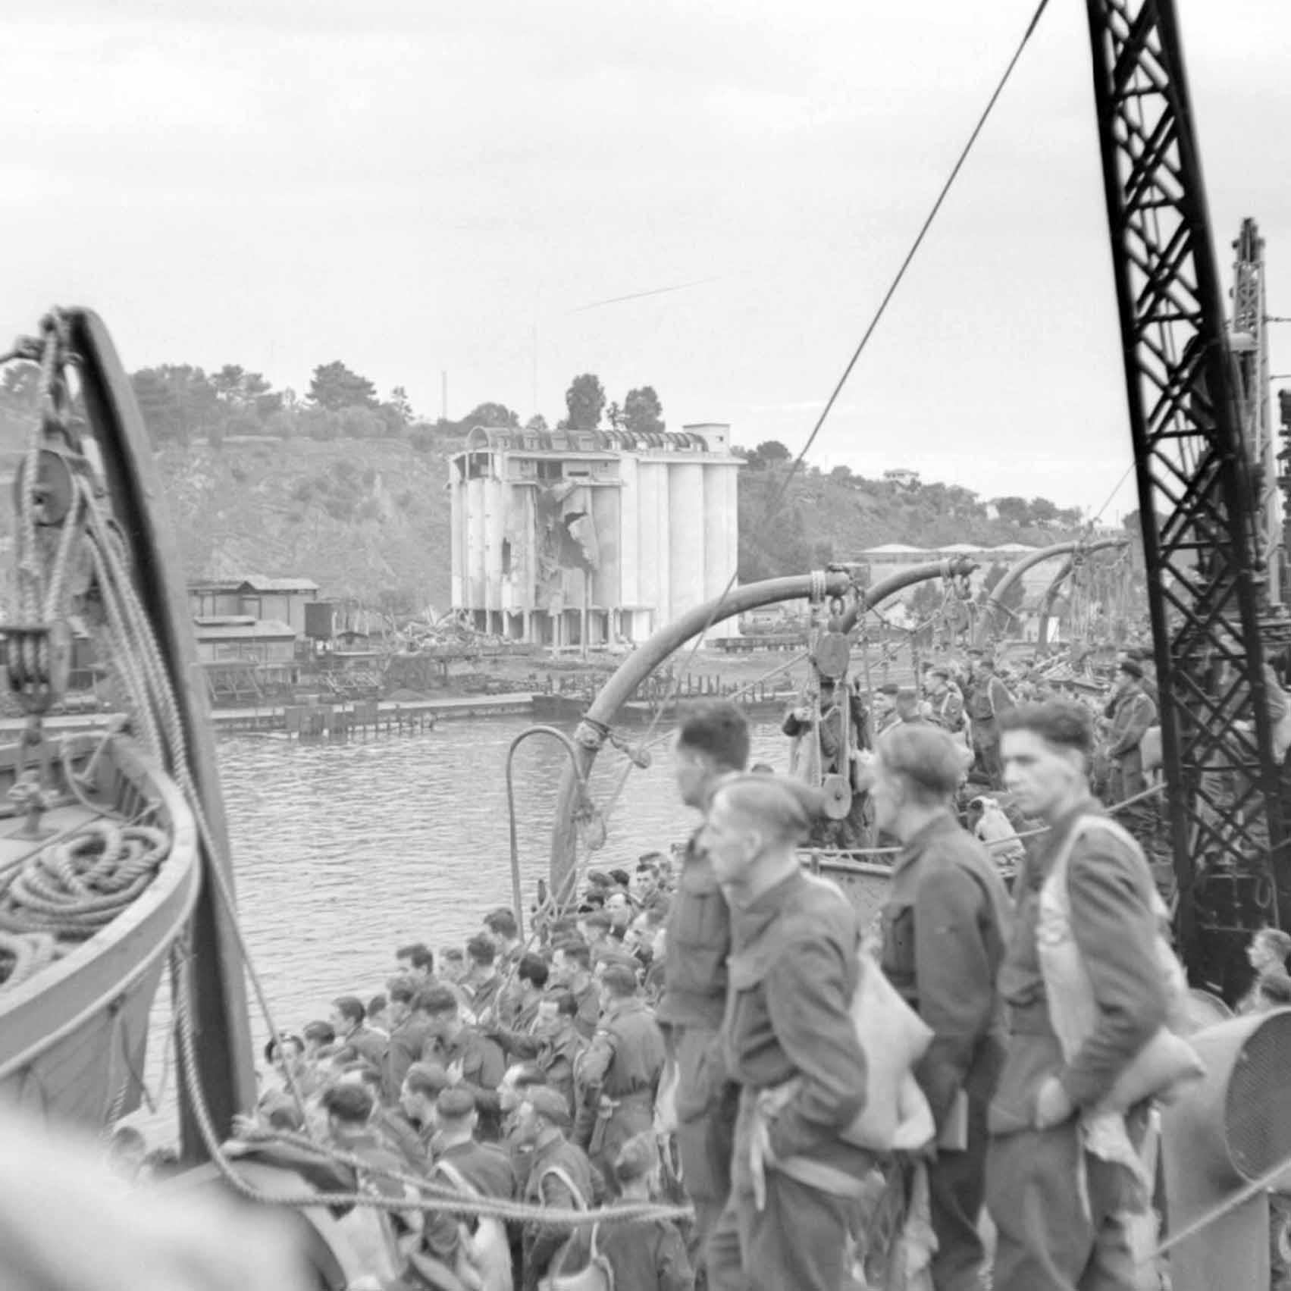
British troops arriving at Bone (Annaba), Algeria, aboard a Royal Navy transport ship, 5 December 1942.
More troops from both sides were arriving in Tunisia. The Germans were doing their best to bring in reinforcements. Hitler was following a policy of never giving ground anywhere, despite the fact that he was no longer capable of mounting offensive operations in North Africa and a final showdown loomed.
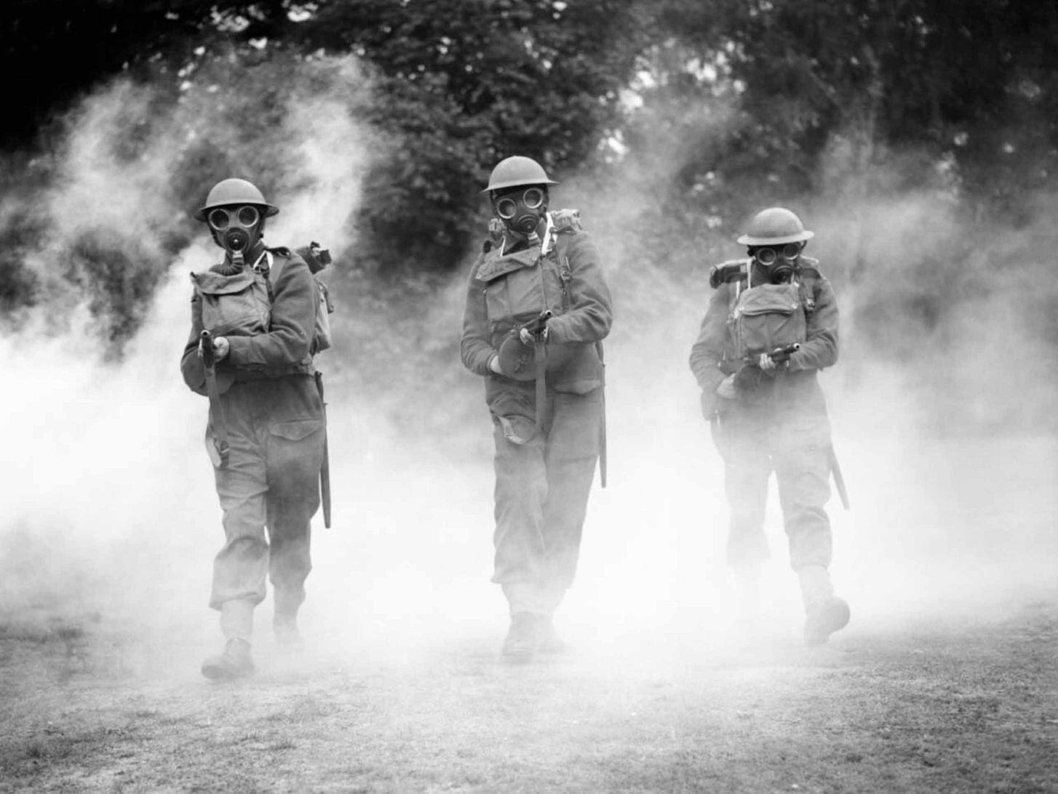
The Irish Guards, training with ‘Tommy Guns’, in 1940.
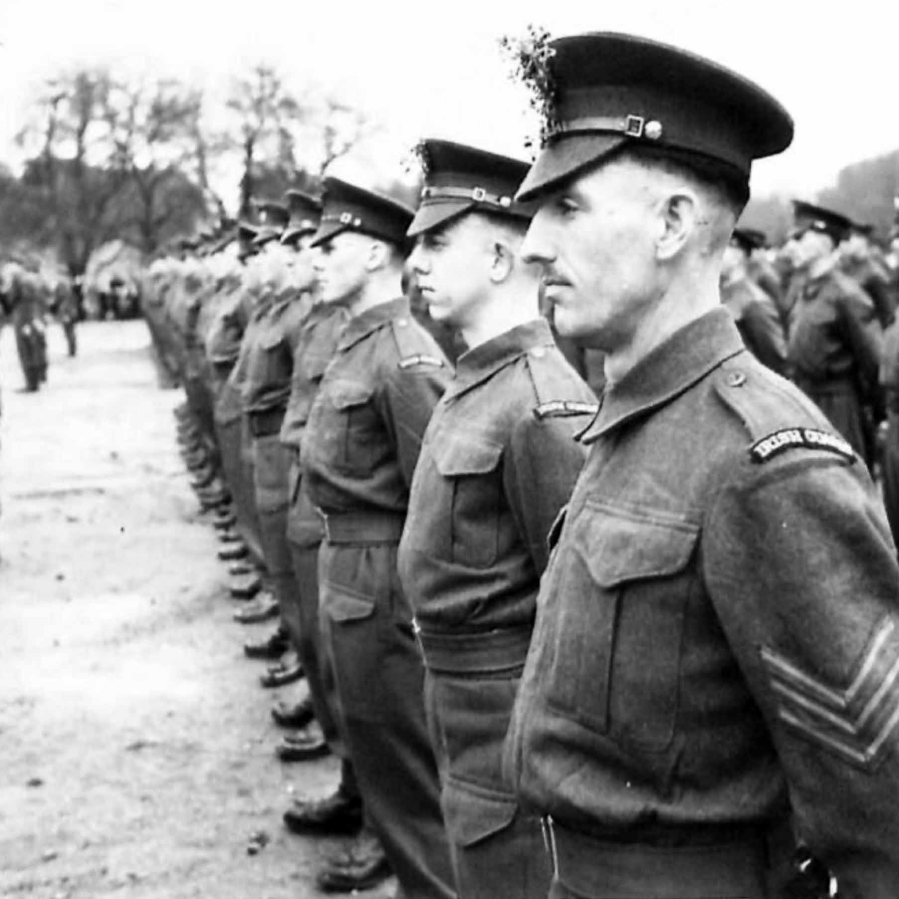
A battalion of the Irish Guards after receiving their Shamrocks on the St Patrick’s Day Parade, 1942.
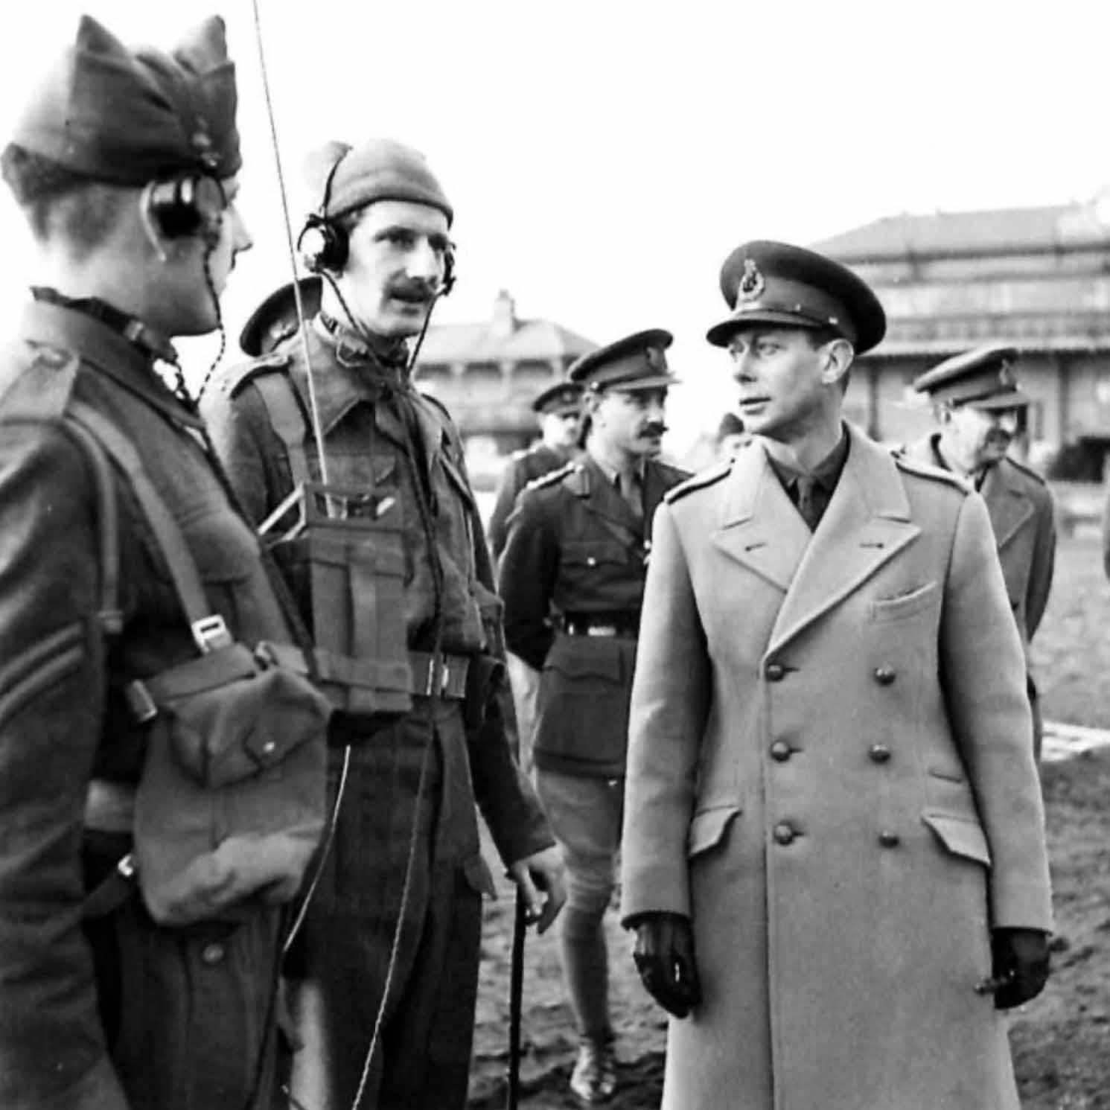
The King inspecting 1st Battalion Irish Guards, February 1943. His Majesty stops to talk to an officer of the Field Signals.
The Irish Guards was one of the famous regiments in the latest batch of British troops to arrive. Amongst many colourful characters in their ranks was John Keneally, better known to his mother and the Honourable Artillery Company, as Leslie Jackson.
The Leslie Jackson who had served in the Honourable Artillery Company had a reputation as a good soldier but a poor discipline record, a record which denied him the chance of transferring to his preferred regiment, the Irish Guards. It had not stopped him from finding another route. Which was why he was now known as John Keneally¹.
Now he was where he wanted to be - and he was spoiling for a fight:
At Bone we did a day’s drill in preparation for a St Patrick’s Day parade on 17th March. This is a big day for the Irish Guards and is always celebrated, no matter where the regiment finds itself.
The great day was warm and sunny. We formed up and each man received a small piece of shamrock which had been flown out by General Alexander, who was the overall commander of both the 1st and 8th Armies. With the shamrock had come a message from the General (who was an Irish Guardsman himself): ‘Welcome to the Micks. Now we will get cracking’
We marched past the Transit Camp Commander with the battalion pipes and drums in full flow, watched by a large contingent of American troops with whom we became very pally afterwards. After the parade we were allowed the rest of the day off.
Within three hours the town was in uproar. The lads had been drinking the local wine as if it were the ale they were used to. The results were dramatic: fights broke out, windows were smashed and soon the Military Police were dragging soldiers away.
Most of us headed like excited schoolboys for the port of Bone to see what delights it had to offer. Michael and I palled up with a couple of GIs who knew their way around. Within three hours the town was in uproar. The lads had been drinking the local wine as if it were the ale they were used to. The results were dramatic: fights broke out, windows were smashed and soon the Military Police were dragging soldiers away. It turned out to be quite a night in the best Irish tradition.
It was the last St Patrick’s Day most of the battalion were ever going to see.
Next morning, we were roused early. We were going into the line at Béja, where the situation was critical. This was it, we were going into action. Halfway to Béja, a large staff car came thundering past us, full of red-tabbed staff officers who stopped the CO at the head of the convoy.
Word passed down the line. Change of plan. The position of Medjez El Bab was even more critical. It was here that the Irish Guards were to play their part in the various actions that would culminate in the fall of Tunis and the collapse of the German forces in North Africa.
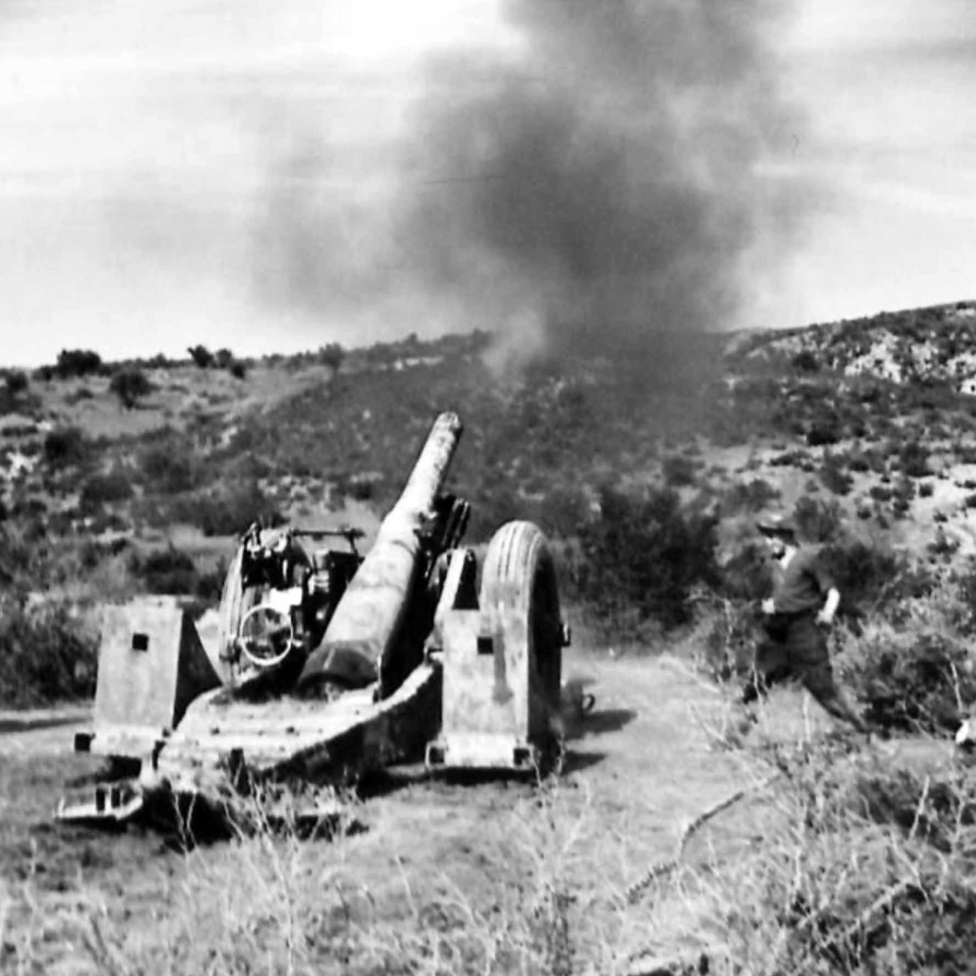
British Heavy Artillery in action on the Medjez-El-Bab Front, Tunisia, 'Away goes 204 lbs of High Explosive.' 1st March 1943.
1
John Keneally: The Honour and the Shame

